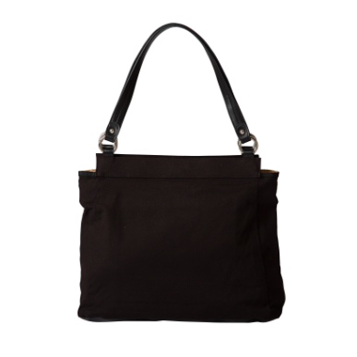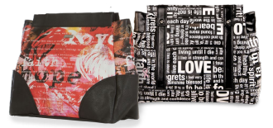

Can’t wait?

Take one home today with a $50.00 donation

Retail Value

$75

For additional tickets contact:

Anne-Marie McCarthy

508-244-9824

amccarthy0630@gmail.com

*Relay for Life of Raleigh*

## Prima base bag and hope shell

Enter to win one of these lovely handbags.

$5.00 each

One of each style will be awarded every hour while supplies last!! Drawings will be held during the Relay for Life of Raleigh!!!

May 29-30, 2015

Leesville Road HS

8409 Leesville Rd

Raleigh